Exp 18:VMware Workstation — Change Hardware Compatibility of an Existing VM

Aim
Adjust a VM’s virtual hardware compatibility (VM hardware version) to match a different Workstation/ESXi level.
Procedure
- Power off the VM → Manage → Change Hardware Compatibility….
- Pick the desired Hardware compatibility level (e.g., Workstation 15.x/16.x/17.x).
- Choose whether to Create a new clone or Alter this VM in place.
- Review devices that may change (e.g., controllers, firmware) → Finish.
- Open Settings to confirm CPU/RAM/Network/Display/Controller options are correct.
- Power on the VM; reinstall/upgrade VMware Tools if prompted and verify devices in the guest OS.
Output
Figure 1 Virtual Machine with 1 CPU, 2 GB RAM, and 15 GB storage
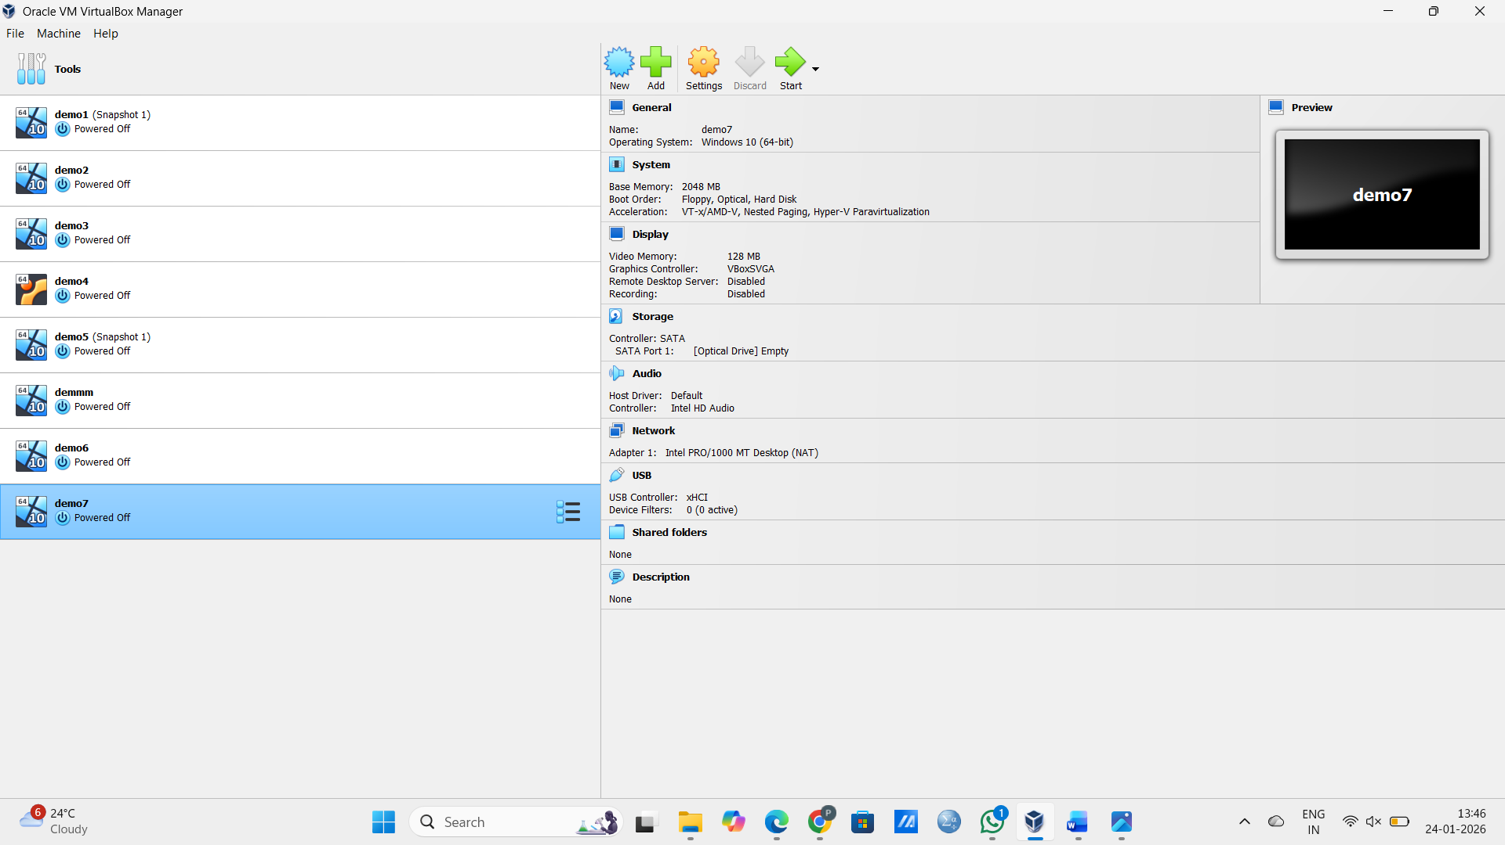

Result
The VM now targets the selected VMware hardware version and boots correctly with compatible virtual devices.

